Netspective Enterprise Frameworks Suite
Building Robust, Cost-Effective J2EE Applications Faster

White Paper

Palmer Business Park
4550 Forbes Blvd, Suite 320
Lanham, MD 20706
(301) 879-3321
http://www.netspective.com
info@netspective.com
Table of Contents

Executive Summary 4
Introduction 5
Java 2 Platform, Enterprise Edition (J2EE) 5
The Challenges 5
Customer Satisfaction 5
Business Functionality 5
Design Issues 5
Coding Issues 6
Deployment Issues 6
Security Issues 6
Maintenance / Reusability Issues 6
Maintaining Quality 6
Team Productivity 7
Development Process 7
Process Artifacts / Documentation 7
Project Management 7
The Solution – Framework 7
Types of Frameworks 8
Benefits [TODO] 8
Need for a frameworks suite [TODO] 8
What is NEFS 8
NEFS Components 8
Commons Core Library 9
Axiom Relational Data Management Service (Data Management Layer) 9
Sparx Application Platform (Presentation and Application Layers) 9
Enterprise Console 9
How NEF Libraries Fit In Your Application 10
NEF Artifacts 10
NEF Web Services 11
NEFS Key Concepts 11
The NEF Project File 11
The com.netspective.sparx.Project class 12
The XML Data Model (XDM) 13
Overview 13
XDM Features 14
XDM Performance 14
XDM Tags versus JSP Tags 14
Value Sources 15
Commands 15
NEFS Features 15
General 15
Architecture 16
Process and Methodology 16
Presentation Layer (Sparx) 16
Data Management Layer (Axiom) 16
Security and Personalization Layer 17
NEFS Benefits [TODO] 17
Alternative Frameworks 17
Custom Frameworks 17
Application Server 18
Embedded Frameworks 18
Open Source Frameworks 18
NEF vs. Alternative Frameworks 19
Conclusion [TODO] 19
How to get further info on NEFS 19
References 19

Executive Summary
In today’s world of Internet-speed development, the time-to-market a product plays even more crucial a role in the success of any business than ever before. To overcome this challenge, enterprises are seeking ways to boost their competitiveness. They are trying to market their applications quickly and affordably, while adding value through increased customer satisfaction.
Many enterprises use Sun Microsystems’ Java 2 Platform, Enterprise Edition (J2EE) to enable the software developers to reduce development cost and time-to-market by simplifying problems relating to development, deployment and management of multi-tier applications. Even though J2EE provides many benefits such as simplicity, portability, scalability, and increased productivity, it poses certain challenges as well.
Since conventional Java developers are not able to handle all the complexities of J2EE, it becomes very difficult for the enterprises to develop and deploy robust J2EE applications without the help of experts, which are already scarce in number. Secondly, J2EE applications require complex and extensive middle layer coding using thousands of available APIs. This increases the development time. In addition to that, a lot of other issues - such as prototyping, unit testing, and project documentation - also affect the overall development time and effort.
Frameworks, with their implementation of design patterns, code libraries, code generators, knowledgebase, and document templates present a good solution to these problems. Different types of frameworks such as template engines, event models, presentation frameworks, and architectural frameworks have been designed to cater for the varying needs of a development team. Many commercial and open-source implementations of these frameworks are available.

The shortcoming of the existing frameworks is that they take care of only a few aspects of the project development cycle. To take full advantage of the framework ideology, companies are required to work with multiple frameworks simultaneously. This introduces additional learning, implementation and integration efforts as well as new technology investments which cancel out the benefits provided by these frameworks.

Netspective Enterprise Frameworks Suite (NEFS) is a comprehensive application frameworks suite for building enterprise-level applications, which create new business value on top of existing business logic, without needing to modify or replace existing technology investments. It improves application quality and developer productivity as well as reduces time-to-market by eliminating repetitive coding through an extensive library of pre-built and well-tested e-business functionality and database components. This results in increased customer satisfaction through implementation of required functionality.
NEFS requires less-qualified engineers to complete a project by using XML to code in a declarative style instead of a programmatic style. It also reduces the number of engineers on a project by producing and automatically maintaining process artifacts like unit tests and documentation. Design and prototyping, professional user interfaces, implementation, documentation, and production logs and metrics are just some of the development deliverables and phases that the NEFS helps accelerate and standardize.

Introduction
To compete in today’s digital economy, companies must be able to develop high-quality software systems at “Internet speed” -- that is, deliver new systems and services to customers with more value and at a faster pace than ever before. One study of this phenomenon reveals “a desperate rush-to-market” and “a new and unique software market environment” as its implications [1]. The same study also observes that the development speed, not the cost or quality, drive Internet-speed software development. In a marketplace with shorter release cycles, companies must deploy new features quickly or competitors will get out there earlier and snatch away customers.

These factors create a pressure on the stakeholders and the development teams. Working in such an environment changes how software development is organized. Companies are now adopting software development methodologies such as Rational Unified Processes (RUP) and eXtreme Programming (XP) to cope up with challenges of faster delivery in an increasingly demanding market.

Java 2 Platform, Enterprise Edition (J2EE)
In addition to adopting new development methodologies, many companies are also making use of development technologies such as Java 2 Platform, Enterprise Edition (J2EE) that support faster development of scalable and portable multi-tier applications for enterprises. J2EE is targeted to simplify enterprise applications by basing them on standardized, modular components, by providing a complete set of services to those components, and by handling many details of application behavior automatically [3].

The Challenges
Even though J2EE along with programming paradigms such as eXtreme Programming (XP) and Rational Unified Process (RUP) significantly reduce the development time and cost, there are many problems associated with their use. Each phase of application development cycle brings its own challenges.

Customer Satisfaction
The competitive market pressure results in rapidly-changing requirements. When requirements are fuzzy and fast-changing, intimate access to customers slashes time delays and ensures that high-priority features are correctly identified. This, however, poses the following challenges:
- Reduced time for creating application mockups and prototypes
- Need to create full-fledged navigation, page flow, and forms mockup while working with the customers who are embedded into the development team
- Quickly creating impressive and creative web designs and GUI layouts that impress the customers
- Need to incorporate customer ideas and requirements into apps “in a matter of hours”
- How to customize UIs and themes on role-basis

Business Functionality
Many existing applications face the following problems associated with business functionality:
- Missing business functionality in the final app because of time spent on infrastructure coding
- Implementing repetitive business functionality “from scratch”

Design Issues
Several design-related issues face the architects when designing J2EE applications:
- How to create stable app design using standard design patterns
- How to avoid rigid, monolithic and brittle design
- Determining which J2EE services to use
- Taking decision on the appropriate use of complex J2EE components such as JNDI, JMS, JDBC, JNI, servlets and JSPs.
- Separating server-side/transport data formats from the GUI
- Providing sound mechanisms for event management, application flows, and widget control
- Dividing application’s visual entities (panels, components, etc.) into panes with specific, consistent responsibilities and functions
- Separating GUI layout from GUI feature code (validation, events), application flow, navigation, server interaction, and business logic
- Separating presentation components from service components
- Defining and orchestrating the interaction between the presentation and service components
- Designing presentation layer to provide strong, orderly way to implement app logic and flow
- How to provide Wireless, and PDA support

Coding Issues
- How to master thousands of J2EE APIs
- How to reduce the time spent on writing DAOs, VOs and wrapper objects for persistence layer
- A different set of coding skills are needed for writing the EJBs, Servlets, and JSPs

Deployment Issues
- How to define and manage server configuration parameters and deployment descriptors
- Properly specifying JAR/WAR files to contain right data on EJB classes, bean type, etc.
- How to manage platform-specific data and files
- How to define and manage app configurations
- How to provide environments for development, debugging and production phases

Security Issues
- How to integrate security, privacy, and encryption on page, field, and business rule levels
- How to provide role-based and security
- How to define and manage hierarchical permissions and roles management

Maintenance / Reusability Issues
Maximization of reusable components results in fast-paced development. This reuse is needed at business logic, interfaces, and backend infrastructure levels. The issues to be considered are:
- How to reduce the amount of code to be written for an app by repeated use of successful coding experience
- How to avoid additional coding efforts inherent in traditional reuse of components
- How to increase code reusability by removing problems such as SQL embedded inside Java code that are common in existing application infrastructures
- How to implement dependency inversion principles to ensure easy maintenance

Maintaining Quality
- How to increase customer satisfaction by maintain app quality
- How to build test harnesses faster

Process Artifacts / Documentation
Part of every J2EE application development process is spent in technical writing. So even if your code is completed on time, this task takes up a lot of the total project resources. The associated challenges are:

- How to create software process and app implementation artifacts quickly
- How to keep the artifacts accurate and up-to-date
- How to find skilled technical writers

Team Productivity
- How to increase productivity of junior programmers
- How can the junior programmers use existing skill set to start building J2EE apps
- How to reduce the number of expert engineers need for a project
- How to use the available expert resources effectively
- How to incorporate code collaboration to improve team productivity

Development Process
Programming paradigms like XP and RUP have exploded into the developer community due to the high demand for a more controlled engineering process. Although the benefits for such paradigms are tremendous, there are increased risks of project failures, the causes for which being:
- higher learning curve
- Development time spent on creation of software process artifacts

Project Management
- How to obtain and analyze metrics (function points, SLOC etc.) to monitor app performance
- How to reduce development costs by reducing the number of expert developers, web designers, and technical writers
- How to monitor team productivity

The Solution – Framework
The aforementioned challenges can be handled by using software reusability. One approach to this is reusable program modules. However, adaptation of these modules requires editing of code or importing the component and changing the aspects that are unsuitable for the system being built [2]. Frameworks take software reusability to the next level.

"A framework is a partially complete software system that is intended to be instantiated. It defines the architecture for a family of systems and provides the basic building blocks to create them. It also defines the places where adaptations for specific functionality should be made." (Buschmann 1996)
Table: Anatomy of a Framework
Feature | Description
Knowledge base | Product reviews, configuration information, lessons learned
Document Templates | Requirements, Use Cases, Design Specs, Test Plans, etc.
Design Patterns /  Standards | Coding and naming standards, proven design strategies, etc.
Code Libraries | Base classes, format utilities, tag libraries, etc.
Code Templates and  Generators | Automated generation of starting code, based on templates
To be useful, a framework should be reusable, extensible, well documented, it should contain functionality useful across a wide variety of application domains, and it should be easy to learn.

Types of Frameworks
Different types of frameworks have been designed with corresponding open source and commercial applications. The following tables list some of the important ones:

Framework Type | Examples
Template Engines | FreeMarker, Velocity, WebMacro
MVC 2 based Presentation Frameworks | Struts, Maverick, Webwork
MVC2 based Architectural Frameworks | Expresso, Tapestry, Turbine
Vertical Frameworks | Oracle Business Framework

Benefits [TODO]
Just add a paragraph outlining basic benefits of frameworks.

Need for a frameworks suite [TODO]
Here we justify the need of a complete suite of frameworks taking care of different aspects of application development, unlike existing frameworks that handle some aspects of the development. Something that takes cares of all phases of a project’s lifecycle.

What is NEFS
The Netspective Enterprise Frameworks Suite (NEFS) is a comprehensive application frameworks suite which helps build secure data-driven web applications. Design and prototyping, implementation, unit tests, implementation documentation, and production logs and metrics are just some of the development deliverables and phases that the NEF helps accelerate and standardize.

NEFS Components
The NEF suite comprises multiple libraries and frameworks, all of which are designed to work together.
Figure 1.1: Overview of NEF Components
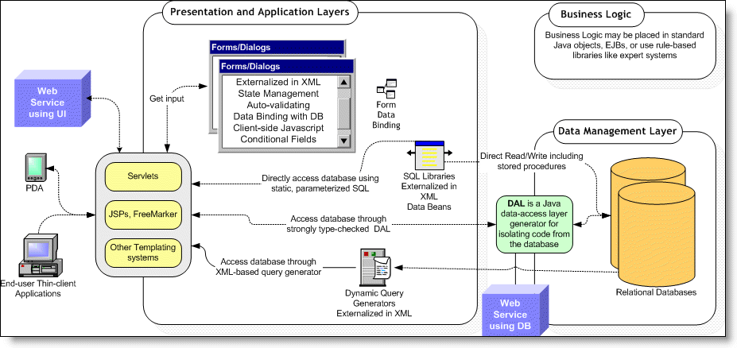

Commons Core Library
The Commons library contains general purpose classes for access control, configuration management, value sources, data validation, and XML parsing. The Commons library may be used in both web-based and non-web-based applications.

Axiom Relational Data Management Service (Data Management Layer)
The Axiom service provides static query, dynamic query (query definitions), and schema management functionality. Axiom is a sophisticated relational database management framework that provides the capability to completely manage schemas, SQL DDL, SQL DML, XML import/export, and vendor-independent persistence. The Axiom framework depends upon the Commons library and may be used in both web-based and non-web-based applications.

Sparx Application Platform (Presentation and Application Layers)
The Sparx application framework helps manage navigation, dialogs (forms), reports, and other complex user interface functionality. Sparx helps create sophisticated yet easy-to-use user interfaces on all common browsers including Microsoft Internet Explorer, Mozilla, and Opera. The Sparx framework is built using Commons and Axiom and is designed exclusively for creating web-based thin-client applications.

Enterprise Console
The NEF and all application components built with it can be viewed with the Netspective Enterprise Console servlet. Each application has a private instance of the Console. It serves as a central repository for the project containing all the implementation and design documentation. It provides facilities for collaborative unit/integrated testing of presentation and data management layer. It also supports central management of connection pools to identify open and leaked connections. In addition to that, console can be used for monitoring project metrics as well as database and security policies.
The Enterprise Console is an optional component for every application built with NEF and it is turned on by default. The programmers may decide to turn it off completely for their applications or secure it differently. The console is an excellent example of one of NEF's features called multiple sub-applications. It means that a primary application can host and co-exist with other shared sub-applications that may be related. The sub-application scheme uses the standard servlet context mapping scheme of the URI paths used by servlet containers. Each sub-application is merely another servlet and can share (if it needs to) the main-application's themes, skins, and descriptors or may use its own.

How NEF Libraries Fit In Your Application
NEF components are pure Java libraries that reside inside your application, unlike other similar frameworks which are containers for your application. The main difference is interoperability of frameworks. Netspective Frameworks are designed as enterprise frameworks that can stand-alone or enhance other COTS or in-house frameworks. NEF consists of three JAR files containing the Commons, Axiom, and Sparx binaries and a set of HTML and XML resources like XSLT style sheets, icons and an extensive JavaScript library. This simple structure affords developers a great deal of flexibility in how they want to use any of the Netspective Frameworks. Therefore, they do not have to redesign or recode their applications as they would to comply with the limitations of a framework container. Instead, they can start out by using a few Sparx features here and there and adopting more of the Sparx ease and speed of development as the need arises. And, because the frameworks all work like normal Java libraries, version control, debugging, and code management is not affected.
Figure 1.2. NEF Position in J2EE Stack
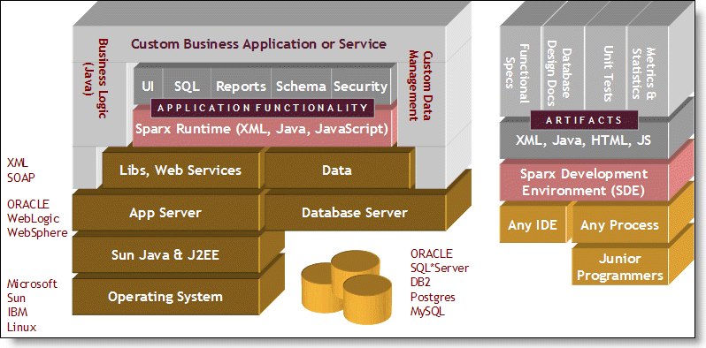

NEF Artifacts
Using simple XML declarations for the items on the left (schema, SQL, UI, etc.) NEF produces a variety of objects and artifacts. Many of the components that NEF produces are not generated but instantiated while others are both generated first then instanatiated. The WEB-INF/classes/auto directory contains all classes that are generated. So, if a class is found in directory other than WEB-INF/classes/auto (the auto-generation directory) then it's a custom or user class that was created or prepared outside of NEF. NEF loads most components using XML which is translated at the startup of the application into objects that are cached, shared, and executed. Unlike most code generators which create code that must be separately compiled, many of the NEF components automatically executed in memory with no compile/link/debug cycle.
Figure 1.3. NEF Artifacts
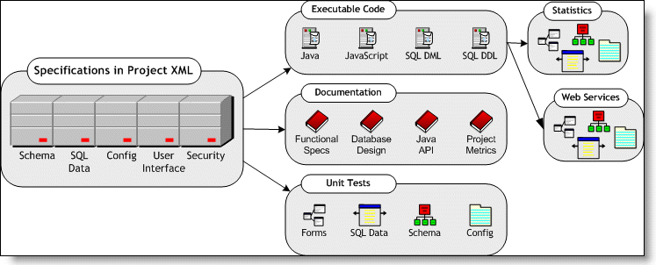

NEF Web Services
The general topic of web services refers to the ability of applications and systems to speak to each other over Internet protocols. The "normal" case of web applications has a customer accessing a catalog site and making a purchase over a secure website. This interaction is quite common but sometimes its preferable to have a computer system automatically place an order with other computer systems. For example, suppliers could provide web services to large corporations so that corporations could automatically, without human intervention, place orders to the supplier when their inventory runs low. NEF supports both web applications (where a human being is interacting with an application or computer system) and web services (where a service is being created for use by other computers). NEF allows the web services to automatically become applications and applications to automatically become services with very little work on the part of analysts or programmers. For example, every Sparx form or dialog automatically provides the capability for becoming a web service. Additionally, any table or SQL query defined using Sparx automatically has the capability to run in both "application" and "service" modes.

NEFS Key Concepts

The NEF Project File
All of the NEF (Sparx, Axiom, and Commons) components are declared in an input source file known as the Project File. The Project File may be either a single file with all components or may be broken up into multiple files and pulled into the main Project File by using <xdm:include> tags.

Example: Basic NEF Project File
<?xml version="1.0"?>
<project xmlns:xdm="http://www.netspective.org/Framework/Commons/XMLDataModel">
<xdm:include resource="com/netspective/commons/conf/commons.xml"/>
<xdm:include resource="com/netspective/axiom/conf/axiom.xml"/>
<xdm:include resource="com/netspective/sparx/conf/sparx.xml"/>
<xdm:include resource="com/netspective/sparx/conf/console.xml"/>

<!-- Your application tags go here. -->

<xdm:include file="your/own/file.xml"/>

<!-- Your other application tags go here. -->
</project>

The com.netspective.sparx.Project class
All of the tags that are processed in the NEF Project file are managed by Java classes. The class that manages the XML root <project> tag is called com.netspective.sparx.ProjectComponent. The ProjectComponent class owns an instance of the com.netspective.sparx.Project class. The Project class then has ownership of all of the tags contained within the <project> tag.

Figure: Overview of Classes Involved in Parsing and Processing the <project> tag
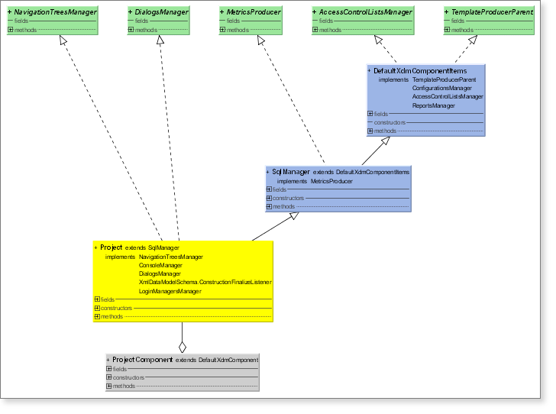

The XML Data Model (XDM)
The eXtensible Markup Language (XML) plays an important role in NEF's ease of use, extensibility, and code generation. All dialogs, fields, validation rules, some conditional processing, all SQL statements, dynamic queries, configuration files, database schemas, and many other resources are stored in XML files that are re-usable across applications. Although XML is the preferred method for creating resource files, almost anything that can be specified in XML can also be specified using the NEF Java APIs. NEF uses the JAXP and SAX standards for parsing and processing XML files.
XML is not used as yet another imperative programming or expression language like Java, C/C++, or Pascal. Instead, it is simply used to declare classes, rules, specifications, and other application requirements that are automatically parsed, read, cached, and executed by one or more NEF components. The dynamic aspects of NEF applications comes from Java through the use of Value Source and Command interfaces, not a new programming language.

Overview
XML Data Model (XDM) is designed to help Java programmers construct and configure Java objects using XML files without worrying about parsing and error checking. The NEF project file uses XDM to declare all project components. The primary objective is to declare your object's data and structure in XML and have XDM automatically construct the objects and assign the data provided in an XML file with almost no performance penalties. XDM does not introduce a new language nor does it replace Java classes, methods, or business logic. The main use for XDM is to allow you to use resource files (XML) to declare the hierarchy and initial data model (state) of your objects. The reason there is almost no performance penalty is that the XDM simply reads the XML and invokes the exact same constructors and methods in your classes exactly as if you had done so by manually writing Java code (including inheritance and composition).

XDM Features
- XDM automatically translates XML tags and attributes to your object hierarchy and data model with no manual mapping or configuration.
- XDM uses simple JavaBeans naming standards and the Java Reflection API to instantiate and initialize the objects declared in the XML resource files.
  - XML elements (tags) are instantiated into runtime objects exactly as if you called the object constructor in Java code.
  - XML attributes invoke Java class mutator (setter) methods exactly as if you called the set method in Java code.
  - XML element text (PCDATA) may be automatically appended using configurable method calls.
  - XML child elements that have element content can be configured to create child objects or call mutator (setter) methods. This allows you to use the element or attribute style of XML resource files.
  - Automatic type conversion validates and translates text from XML attributes into the proper object's mutator (setter) method parameter types: boolean, int, float, String, etc. Automatic error checking will ensure that when your class setter method parameter type changes, the XDM will automatically validate the new parameter type.
- The translation process is configurable so that you can create element or attribute aliases (so that you can create XML tag and attribute names that may be mapped to different method names in Java than what the JavaBean standards would imply).
- XDM templates provide object composition and inheritance behavior exactly as Java code.
- XDM include files provide the capability to break out large object construction tasks into multiple resource files.
- XDM transformers provide the capability to filter XML files through XSLT or other transformations before object construction takes place.
- Using the factory design pattern, the XML traversal is separated from the object instantiation and method invocation.
- Custom handlers allow portions of XML to be handled manually.

XDM Performance
With NEF, all XML data is cached and only read when it changes. Basically, all NEF XML files are read using lazy-read approach; meaning, they are read only when needed and even then only once. So, the majority of all NEF XML performance impacts (if any) occur at the startup of a server-based application. Once the application starts all data is cached and shared across users and XML-related performance issues are eliminated. Also, NEF relies on the SAX programming interface for XML parsing and processing thus requiring far less memory and performance overhead than frameworks that rely on DOM interface.

XDM Tags versus JSP Tags
JSP tag libraries are usually used for emitting HTML. They are commonly used in the view component of the MVC paradigm. NEF XML tags are used to describe and declare all aspects of your application (UI, database, security, etc). NEF can use existing JSP tag libraries but they are seldom needed because NEF's Sparx framework handles most tasks within its own, much simpler, and much more powerful XML tags.

Value Sources
Value sources allows dynamic data to be included in XML without creating a programming language inside XML. There are many locations in the Project where value sources are used: configuration variables, forms, SQL statements and SQL bind parameters. Value sources allow common business logic and business values to be stored in shareable instance and then used either in XML or Java files where necessary. Value sources can be either single or multiple (list context) and are used anywhere dynamic data is required.

Figure 3.3. Value Sources Overview
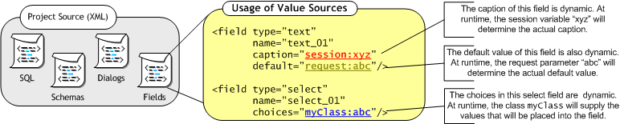

Commands
Commands are Java classes that execute arbitrary tasks defined either by you or the framework. They are used to encapsulate common logic and reuse that logic across pages and dialogs/forms.

NEFS Features
The NEF has hundreds of features that support the development of sophisticated applications with exceptional ease.

General
NEF General Features
Declarative web application development | OS and App-server independence
Works with any IDE, editor, studio apps | Supports total lifecycle of development
Junior-level programmer competency  Required | Uses normal Java inheritance and delegation for extensiblity
Works but does not require EJB | Native J2EE API always available
Improves debugging by using the integrated Jakarta Commons Logging engine. | Automate your builds using the integrated Ant build engine and supplied build files.
Collaborate with other developers across the room or across the world using only a browser. | Ability to version-control components and apps
Works well with other frameworks like Struts | Capability of migrating to .NET
Encapsulate app functionality into commands and increase reuse across projects. | Encapsulate business values logic into objects that be reused across modules and projects.

Architecture
NEF Architectural Features
Executable specifications - rules declared in XML automatically produce app logic | Plug-in architecture to replace any framework classes with custom classes
All object construction of UI, DB, Security performed in external XML files | Fully integrated security, UI, persistence, and business logic frameworks
Automatic code generation | Business rules and values repository reusable across applications
Support for web services | Logging and Performance Stats
Large library of J2EE design/architecture patterns | Large library of application integration and functionality patterns
Centralized configuration parameter through XML-based properties files with support for variables, includes | Allows production, testing, development modes and allows apps with conditional logic capability

Process and Methodology
NEF Process and Methodology Features
Web-based administration console allows visualization and management of all framework objects | Automatic unit test harnesses of major application components
Basic end-user integration testing with no programmer intervention | Unit Testing of Custom Components (using Junit)
Automatic generation of functional specifications and implementation documents | Automatic generation of function points, SLOCs, and other application metrics

Presentation Layer (Sparx)
NEF Presentation Layer Features
Control complex application behavior with integrated security and navigation personalized to individual users or roles. | Develop sophisticated multi-module single-sign-on apps using one Servlet context.
Leverage built-in report writers and XSLT transformers or connect to your favorite reporting engine. | Create auto-validated forms with dozens of built-in field types that easily handle and recover from all user errors.
Use your favorite template engine for content: JSP, FreeMarker, Velocity, Tea, etc. | Develop apps that have a consistent UI that can switch looks and feel without code changes.
100% declarative navigation, workflow, forms and controls with no JSP or custom tag needed | Automatically run SQL to bind data in forms/fields/pages
Includes professionally designed navigation, forms, reports and styles which reduce the need for graphics artists | Automatic declarative server- and client-side validation, controls, keypress filters and data formatting
Complete HTML generation of forms (without JSP or templates required) | Wireless, PDA, Browser Support

Data Management Layer (Axiom)
NEF Data Management Layer Features
Create vendor-independent relational tables (in XML and Java-based meta data) and generate SQL DDL, DAOs, and XML import/exporters. | Isolate database-specific functionality such as auto-inc into delegated objects.
Connect to multiple data sources within a single page | Connection Pooling (both built-in and access to JNDI)
Manage pooled connections centrally to visualize open and leaked connections. | Reusable library of static and dynamic SQL queries kept in XML files
Define SQL in XML and automatically generate Lightweight Data Access Objects (DAOs) with bind variables and statement pooling. | Define SQL rules in XML and let your users enter search criteria that auto-generates SQL with bind variables and joins.
Automatic declarative inserts/updates/deletes of data | Automatic creation of forms to add/edit/delete data from tables
Automatic SQL performance statistics tracked for all static and dynamic SQL | Automatic generation of HTML Design Documentation for Database Schema

Security and Personalization Layer
NEF Data Management Layer Features
Harden your applications with auto-managed users, roles, and permissions. | Declarative permission and role assignment to forms, fields, tables, etc
Automatic support for multiple attempts lockout | Auto-generated login form
Multiple Access Control Lists for cross-app, sub-site, etc | Tracking of all user logins, logout, audit trail
Ability to integrate with other commercial or custom single-sign-on solutions | Authentication and authorization may be extended using JAAS/custom security classes

NEFS Benefits [TODO]

Alternative Frameworks
There are several alternative frameworks available but they offer only partial solutions to the problems at hand.

Custom Frameworks
Due to the lack of robust commercial offerings, today most enterprises choose to build their own frameworks and platforms. These In-house and home-grown solutions tend to have a great deal of momentum behind them because they may be favored internally by the experienced and senior engineers that construct them. However, home-grown solutions exhibit the following shortcomings:
- They often have limited features
- They are usually poorly documented.
- They are notoriously difficult to extend because they are usually designed for special-purpose jobs.
- They are usually expensive to create and maintain and require engineering attention which is taken away from business requirements. Programmers often end up spending time on infrastructure issues instead of issues that directly affect end-users.
With its unique architecture, NEF can supplement in-house frameworks or replace them completely. It is able to work alongside home-grown solutions and is extensible enough to allow enterprises to make a slow switch over to NEF.
Even if all of your engineers are very experienced and your architecture is very sound, part of every J2EE application development process is spent in prototyping, technical writing, testing, and maintenance. Even if the code is completed on time, these other tasks take up to another 30 to 40% of the total project resources. NEF can take an experienced J2EE programmer and improve their productivity and in many cases eliminate the need for specialized resources for architecture and design, prototyping, documentation, logging, deployment, and maintenance.

Application Server
Most J2EE application servers contain a great deal of common infrastructure code that helps contain, manage, deploy, and execute applications. They also have features the increase scalability, reliability, and availability of applications by providing features like clustering and failover. What they lack, because it’s not part of their product requirements, is the ability to help build the applications they contain. Just as an operating system is a container for executing applications written in any language but does not assist in the development of the applications, a J2EE application server is a container for executing Java and J2EE applications but does not assist in the development of the Java/J2EE applications. Sparx, as a J2EE framework, helps create the applications that you can then deploy onto any J2EE container or application server.

Embedded Frameworks
Many commercial embedded frameworks are provided by application server vendors like WebLogic or WebSphere. The main issues associated with these frameworks are:
- They are usually vendor-specific and tie you to a particular application server, operating system, or database server
- The frameworks are not designed for complete coverage of sophisticated applications and engineers end up having to do a great deal of infrastructure work on their own.
- Most embedded application server frameworks are very light on functionality.
NEF, on the otherhand, can supplement or replace your application server vendor's frameworks with a good mix of easy to use components for faster development and the sophistication that senior architects need to create robust applications. Also, all NEF-based applications are application-server, database-server, and operating-system independent.

Open Source Frameworks
There are many freely-available open source frameworks are quite good for certain types of applications. There are a number of good tools in this category like Struts, Enhydra, Expresso, and others; however, they all share the following issues:
- They have limited features or functionality
- Most of the open source tools cater to very talented Java engineers since they require a serious understanding of low-level computer science concepts, J2EE APIs, and Java programming.
- Most open source tools are written by experienced programmers for experienced programmers and as such depend on mutual understanding instead of heavy documentation.
- While they save money in the beginning (since they are free) they end up costing much more because they often require more experienced engineers, usually require a higher number of engineers, and don't have the quality management tools built-in.
NEF can complement or replace most frameworks like Struts or Expresso.

NEF vs. Alternative Frameworks
There are two primary competitive advantages that Netspective's frameworks have over other frameworks.
Simplification | NEF focuses on pure reduction of time and effort for the engineer and the use of the technology by less-experienced staff members. Also, the expert programmers enjoy working on end-user and application domain tasks instead of grunt coding in the infrastructure.
Holistic approach to engineering | NEF concentrates not just on the coding aspects but the engineering aspects such as testing (quality), metrics (measurement), monitoring performance, and documentation.

Conclusion [TODO]

How to get further info on NEFS
Although a great deal of information has been presented in this document, it’s only a small portion of the information available online and in other documents. The documents and evaluation applications available at http://www.netspective.com will show you:
- How to evaluate NEFS online and on your own system.
- How to create a sample application.
- How to use the Sparx build scripts and NEFS Enterprise Console to help develop your application.

You may also contact our support team at support@netspective.com or call us at +1 (301) 879-3321

References
- R. Baskerville R. Ramesh, et al, “Is Internet-Speed Software Development Different?,” IEEE Software, Nov./Dec. 2003, pp. 70–77.

- J. Bosch, P. Molin, et al, “Object-Oriented Frameworks - Problems & Experiences,” Object-Oriented Application Frameworks, eds. M. Fayad, D. Schmidt, R. Johnson, John Wiley, 1999.

- Java 2 Platform, Enterprise Edition (J2EE) Overview http://java.sun.com/j2ee/overview.html

Component Orientated Approach

